Utah Title I Schoolwide Planning Template

Part A: General Information
School Name The Accelerated School (WV2&3) | LEA Name American Preparatory Academy Date: Sep. 26, 2025

Name | Title I Schoolwide Planning Team | Signature (see SIP signature form)
Lindsey Rees  Rebecca Dailey  Eryn Woolston  Jake Winegar  Trina Christensen  Jonathon Campbell  Lenora Monge  Christopher Nash  Julie Rodriguez  Irena Tatosian-Golon  Ryan Thomas  Natalie Arce  Genesis Valle | Facilitator  Facilitator  Admin  Admin  Afterschool Admin  Afterschool Admin  Parent  Parent  Elementary Teacher  Secondary Teacher  Secondary Teacher  Secondary Student  Secondary Student | 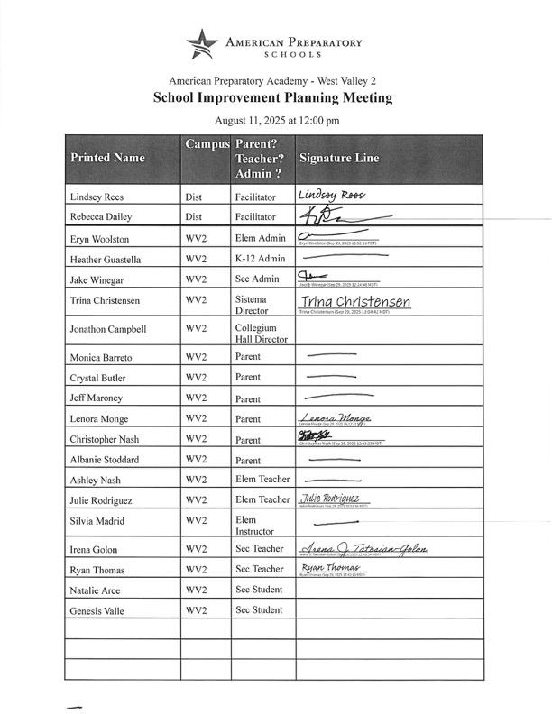
I certify that the development of this Title I Schoolwide Program Plan included the meaningful involvement of the individuals listed above:
Title I Director: Lisa Brunson | Signature: __________________________________
School Director: Jake Winegar | Signature: __________________________________

1. Comprehensive Needs Assessment
ESEA 1114(b)(1)(A)
Refer to item # 6 of the Utah Title I Part A Monitoring Handbook

Schoolwide project schools have conducted a comprehensive needs assessment of the entire school, based on the information about the performance of children in relation to the state content and student performance standards (Utah State Core Curriculum). Quality needs assessments include multiple sources of data. Some to consider are:

Student achievement trends | ✔ | Internal Link to full Comprehensive Needs Assessment Data:  2025 WV2.WV3 CNA - for SIP.xlsx
Graduation rates (for high schools only) | ✔ | 2025 Graduation Rate: 89.0%* of our seniors graduated.  *Official USBE Graduation Rates will be released in October
Demographic data | ✔ | Free/Reduced lunch: 57.53%  Ethnic minorities: 64.19%  Racial Minorities: 19.41%  Students with disabilities: 9.80%  English Learners (EL): 41.51%  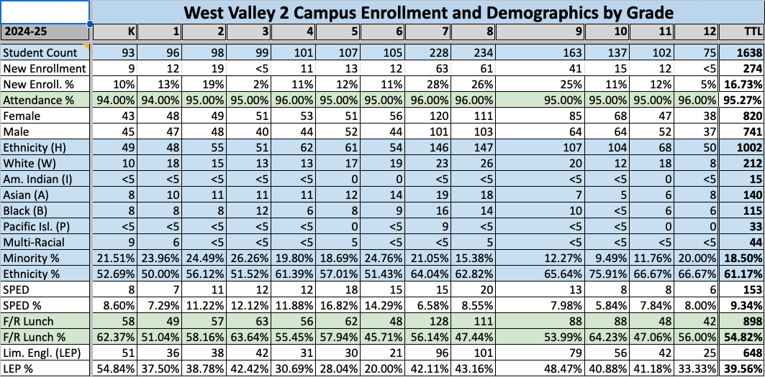
School climate (including safe school data)  Elementary | ✔ | Parent satisfaction: 93.3% of parents are satisfied or very satisfied with the overall performance of the school. 94.2% of parents feel the same way about the academic program of the school. 94.0% of parents feel the same about the school's curriculum, 93.2% about the teachers, 91.7% about the instructors, 89.3% about communication with parents, 87.2% about behavior of the students at school.
School climate (including safe school data)  Secondary | ✔ | Parent satisfaction: 87.0% of parents are satisfied or very satisfied with the overall performance of the school. 92.8% of parents feel the same way about the academic program of the school. 91.6% of parents feel the same about the school's curriculum, 87.9% about the teachers, 89.2% about the instructors, 89.6% about communication with parents, 79.8% about behavior of the students at school.
Course-taking patterns (secondary only) | ✔ | WV2 added a Latin 1010 CE class to WV2 in 2020-21, which increased our district’s high poverty participation in CE from 4 to 25. WV2 added a Latin 1020 CE class in 2021-22. An Economics class was offered starting 2022-23 and is required for all seniors. An AP Seminar class was also added in 2022-23. This is a prerequisite to AP Research, which is now offered beginning school year 2023-24.
Teacher qualifications | ✔ | Highly Effective: 38  Effective: 43  Moderately Effective: 4  Ineffective: 0  Total Teachers: 85  Teacher Effectiveness is comparable to non-Title I APA schools.  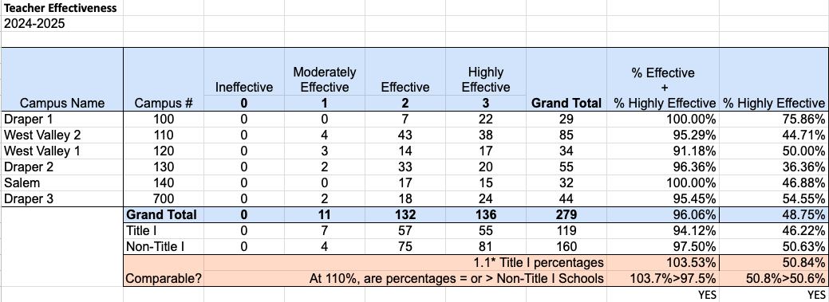
Participation in college entrance testing (high school only) | ✔ | 2025 AP Exams passed (3 or higher): 86/212 taken (40.57%) in 13 subjects.  2025 ACT Mean Scores
   | English | Math | Reading | Science | Composite
  College-Ready Benchmark Score | 37.3% | 27.7% | 28.9% | 22.9% | NA
  Average Score | 16.95 | 18.19 | 18.53 | 18.43 | 18.16

2. Schoolwide Reform Strategies
ESEA 1114(b)(1)(B)
Refer to items #7 and #15 of the Utah Title I Part A Monitoring Handbook

For schools approved by the LEA to operate a schoolwide program, required schoolwide reform strategies are selected and implemented.

Describe the strategies and the accompanying action steps that will be used to improve student achievement. Use the following form to guide the planning. Please duplicate the form on the following page as needed for each goal.

Schoolwide Reform Goals and Strategies Form
(Complete one page for each goal.)

Schoolwide Goals: Goals must be directly related to the results of the comprehensive needs assessment and directly tied to the Utah State Core Curriculum. Goals must be specific, measurable, attainable, realistic and time-based (SMART).
Goal #1 | Progress each student at least one grade level in core subjects (Reading, Language Arts, Mathematics, and Science).
Strategies | Description: Establish every student's present level of performance in Reading, Language Arts, and Mathematics, and record it in a database  Description: Utilize Research-based Instructional Methods & Assessment and track assessment outcomes each week  Description: Ensure all Teachers and Paraprofessionals are expertly trained to improve student academic performance through required, annual pre-service training  Description: Ensure ongoing improvement of teachers and paraprofessionals through individual coaching to improve student academic performance  Description: Teachers will collect performance data on each student weekly, evaluate weekly, and update academic plans as needed to improve student academic performance  Description: Provide technology tools and support for consistent curriculum delivery, data collection, and analysis of student performance  Description: Involve parents in the reading instruction of their student in a consistent, meaningful way.  Description: Provide opportunities for continued student improvement over the summer months  Description: District will plan, monitor and coordinate school efforts to implement the Strategies to ensure student academic achievement.  Description: Provide additional instructional time beyond State requirements via longer school days for all students, academic extended day for at risk students, and afterschool opportunities as funds allow.
Scientifically Based Research Support | Scientifically Based Research supporting Language Arts teaching methods and curriculum:  - https://spalding.org/standards-and-correlations/  - https://www.shurley.com/?3f9b06c8f52a14bd1250a5df0769  - http://ies.ed.gov/ncee/wwc/PracticeGuide.aspx?sid=3  - https://education-consumers.org/pdf/DI_Research.pdf  Scientifically Based Research supporting mathematics teaching methods and curriculum:  - https://www.hmhco.com/~/media/sites/home/education/global/pdf/resources/mathematics/elementary/saxon-math/theoretical-empirical-research-130205.pdf
Expected Impact in Core Academic Areas (How will success be measured on an annual basis?) | The state standardized assessment is administered. Core Knowledge scores in Language Arts will reach or exceed 75% annually. 80% of Secondary students who have been with APA for 3 years or more will meet College Readiness Benchmarks on Explore, Plan, and ACT assessments in at least one subject area.
Professional Development to Support Strategies | See section 4. Professional Development Plan
Timeline | See goal strategies.
Responsible Parties | Carolyn Sharette, Executive Director  Jen Walstad, Academic Executive Director  Eryn Woolston, Elementary Director  Al Ramirez, Junior High Director  Jake Winegar, High School Director  Craig Peterson, Secondary Director
Evaluation Process  (How will the school monitor the implementation of the strategies and action steps associated with this goal?) | The school will monitor the implementation of the strategies and action steps associated with this goal through internal reports, weekly meetings, ongoing assessments, year-end assessments, and a year-end comprehensive needs assessment.

Goal #2 | Provide opportunities for students to become well-rounded and educated in general subjects.
Strategies | Description: Provide classes in music, art, physical education, and history.  Description: Provide civics instruction and service opportunities, and workshops in professionalism, communication, decision-making, and other life-skills training through the Builders/Ambassadors program.
Scientifically Based Research Support | - “The Socioemotional Benefits of the Arts: A New Mandate for Arts Education” Summary Report, April 2017  - Civics Education Research
Expected Impact in Core Academic Areas | The state standardized assessment administered. Acadience Reading, SAT, Core Knowledge, College Readiness, and in-program Assessments will be used to measure academic success. It is anticipated that test scores will demonstrate increased proficiency that align with our school goals.
Professional Development to Support Strategies | See section 4. Professional Development Plan
Timeline | See goal strategies.
Responsible Parties | Carolyn Sharette, Executive Director  Jen Walstad, Academic Executive Director  Eryn Woolston, Elementary Director  Al Ramirez, Junior High Director  Jake Winegar, High School Director  Craig Peterson, Secondary Director
Evaluation Process | The school will monitor the implementation of the strategies and action steps associated with this goal through internal reports, weekly meetings, ongoing assessments, year-end assessments, and a year-end comprehensive needs assessment.

Goal #3 | Ensure students with special needs are identified and provided with appropriate services.
Strategies | Description: Provide a less restrictive learning environment that meets the needs of students with Individualized Education Plans (IEPs)  Description: Provide specific services to qualified students according to the Individuals with Disabilities Education Act (IDEA)  Description: Provide a paraprofessional in every K-6 grade classroom to provide support for students on IEPs.  Description: Provide additional instructional time beyond State requirements via longer school days for all students, academic extended day for at risk students, and afterschool opportunities as funds allow.  Description: Employ staff members to monitor lunch, carpool, playground, and other activities to ensure adequate supervision, enhance social-emotional learning, and positive student culture.
Scientifically Based Research Support | Scientifically Based Research supporting West Valley 2's Special Education (SPED) program:  - http://www.wrightslaw.com/info/lre.incls.rsrch.whitbread.htm  - https://ies.ed.gov/ncee/wwc/FWW/Results?filters=,Children-Youth-with-Disabilities  - http://www.readingrockets.org/article/30676
Expected Impact in Core Academic Areas | The state standardized assessment administered. Acadience Reading,, SAT, Core Knowledge, College Readiness, and in-program Assessments will be used to measure academic success. It is anticipated that test scores will demonstrate increased proficiency that align with our school goals.
Professional Development to Support Strategies | See section 4. Professional Development Plan
Timeline | See goal strategies.
Responsible Parties | Carolyn Sharette, Executive Director  Jen Walstad, Academic Executive Director  Eryn Woolston, Elementary Director  Al Ramirez, Junior High Director  Jake Winegar, High School Director  Craig Peterson, Secondary Director
Evaluation Process | The school will monitor the implementation of the strategies and action steps associated with this goal through internal reports, weekly meetings, ongoing assessments, year-end assessments, IEPs, SPED reports, and a year-end comprehensive needs assessment.

Goal #4 | All students will be educated in learning environments that are safe, drug-free, and conducive to learning.
Strategies | Description: Implementation of Builders Program, with monthly awards to students in all grades.  Description: Implementation of Ambassador Program in secondary grades.  Description: Distribute and analyze school climate surveys annually.  Description: Specific staff members will be assigned to check the building, monitor safety, conduct safety drills, and assist with traffic control.  Description: Employ staff members to monitor lunch, carpool, playground, and other activities to ensure adequate supervision, enhance social-emotional learning, and positive student culture.
Scientifically Based Research Support | Scientifically Based Research supporting West Valley 2's character development and behavior management programs:  - http://ies.ed.gov/ncee/wwc/document.aspx?sid=23  - https://ancorapublishing.com/wp-content/uploads/2021/06/Is-CHAMPS-Evidence-Based.pdf  - https://ies.ed.gov/ncee/WWC/Docs/ReferenceResources/CharEd_protocol.pdf
Expected Impact in Core Academic Areas | The state standardized assessment administered. Acadience Reading,, SAT, Core Knowledge, College Readiness, and in-program Assessments will be used to measure academic success. It is anticipated that test scores will demonstrate increased proficiency that align with our school goals.
Professional Development to Support Strategies | See section 4. Professional Development Plan
Timeline | See goal strategies.
Responsible Parties | Carolyn Sharette, Executive Director  Jen Walstad, Academic Executive Director  Eryn Woolston, Elementary Director  Al Ramirez, Junior High Director  Jake Winegar, High School Director  Craig Peterson, Secondary Director
Evaluation Process | The school will monitor the implementation of the strategies and action steps associated with this goal through internal reports, weekly meetings, behavior intervention reports, operations reports, and character education reports.

Goal #5 | Ensure EL students are identified and provided with appropriate English instruction.
Strategies | Description: Screening assessments will be administered to students.  Description: EL students will be given formative assessments and data will be collected and reported annually.
Scientifically Based Research Support | Use of Evidence-Based, Small-Group Reading Instruction for English Language Learners in Elementary Grades: Secondary-Tier Intervention  - https://journals.sagepub.com/doi/abs/10.2307/30035561
Expected Impact in Core Academic Areas | The state standardized assessment is administered. Acadience Reading, SAT, Core Knowledge, College Readiness, and in-program Assessments will be used to measure academic success. It is anticipated that test scores will demonstrate increased proficiency that align with our school goals.
Professional Development to Support Strategies | See section 4. Professional Development Plan
Timeline | See goal strategies.
Responsible Parties | Carolyn Sharette, Executive Director  Jen Walstad, Executive Academic Director  Eryn Woolston, Elementary Director  Al Ramirez, Junior High Director  Jake Winegar, High School Director  Craig Peterson, Secondary Director
Evaluation Process | The school will monitor the implementation of the strategies and action steps associated with this goal through internal reports, Family School Organization (FSO) participation, parent surveys, volunteer records, Learning Plan compliance, and other records demonstrating parent involvement. Parent Involvement will be assessed in the year-end comprehensive needs assessment.

Goal #6 | Provide effective parental communication and opportunities for parental involvement.
Strategies | Description: All requirements of parental notification, consultation, and other requirements will be met.  Description: Provide parents with information at least annually regarding Title programs, school and student achievement, teacher qualifications, and the School Improvement Plan.  Description: During an annual Stakeholder meeting, parent advisory members will be invited to evaluate school needs and collaborate on the School Improvement Plan, written Parent and Family Engagement policy, and school-parent-student compacts.  Description: Encourage parent volunteers during school and afterschool activities.  Description: Provide technological tools and support to provide effective communication between school and parents.  Description: Progress reports will be continuously updated and available for parents according to APA's Academic Communication policies.  Description: Provide training to parents to assist them in achieving student success.  Description: Provide grade-level specific Summer “Stay Sharp” Packets that assist parents in helping students retain reading and math skills over the summer months.
Scientifically Based Research Support | Scientifically Based Research supporting West Valley 2's parent involvement policies and practices:  - https://www.nea.org/student-success/engaged-families-communities
Expected Impact in Core Academic Areas | The state standardized assessment administered. Acadience Reading, SAT, Core Knowledge, College Readiness, and in-program Assessments will be used to measure academic success. It is anticipated that test scores will demonstrate increased proficiency that align with our school goals.
Professional Development to Support Strategies | See section 4. Professional Development Plan
Timeline | See goal strategies.
Responsible Parties | Carolyn Sharette, Executive Director  Jen Walstad, Academic Executive Director  Eryn Woolston, Elementary Director  Al Ramirez, Junior High Director  Jake Winegar, High School Director  Craig Peterson, Secondary Director
Evaluation Process | The school will monitor the implementation of the strategies and action steps associated with this goal through internal reports, FSO participation, parent surveys, volunteer records, Learning Plan compliance, and other records demonstrating parent involvement. Parent Involvement will be assessed in the year-end comprehensive needs assessment.
Additional School Goals and Improvement Plans
West Valley 2 (Elementary) and West Valley 3 (Secondary) - School Improvement Goals:
Elementary - SY26 WV2 SIP.pdf
Secondary - SY26 WV3 SIP.pdf

3. Regular Monitoring and Plan Revision – ESEA Sec. 1114(b)(3)
The Schoolwide Program strategies are regularly monitored, and revised as necessary, based on evolving student needs.

American Prep uses two data tracking systems, one for homeroom classes and one for Multi-Tier Systems of Support classes. Within these systems, we use a myriad of tools to ensure an outstanding education product and accountability in those teaching it. These tools include the 180-day Plan, Grade Level Homeroom Tracker, Daily Lesson Data Record, Check-out Records, Test Arrays, Lesson Progress Charts, Group Level Overview Forms, End of Year Group Evaluation Forms, and Master Academics.

Homeroom 180-Day Plan and Grade Level Homeroom Tracker
Teachers find their curriculum on the 180-Day plan, which links them to a Google Drive full of teaching materials. They report on the Grade Level Homeroom Tracker which lessons have been taught and which students did not achieve mastery on Accountability Elements (AE). Monthly, district grade level teams meet to review this data. At the end of the school year, district teams review and compile and present this data to administrators during a 5-day Post Service.

Multi-Tier System of Support Class Tools

- Daily Lesson Data Record
The Daily Lesson Data Record (DLDR) is used during reading to track how many turns to read each child has, reading errors they have made, comprehension questions answered correctly and incorrectly, how the student did on their daily speed reading tests and daily homework scores.

- Check-out Records
In reading every 5-10 lessons, teachers fill out a check-out record, marking if the student made it in the targeted time and how many errors were made.

- Test Arrays
In Math, along with recording daily math facts, homework and effort scores, the teachers fill out a test array every 5-10 lessons. The array shows how many points each student missed on individual test questions and the corresponding skill related to that question. It has built in formulas to show teachers suggested skills for re-teaching.

- Lesson Progress Charts
The data from the daily reading and math records is analyzed to fill out the weekly Lesson Progress Chart (LPC). On this document, teachers write what lessons were taught and mark how many of their students were at mastery, 80% or higher, for the week. In addition, they mark which adaptations their students with special needs received that week. On the back of the LPC, teachers create a plan for each student not at mastery to help them achieve mastery the following week. LPCs are delivered to the academic directors who compile them into a campus wide LPC. Directors track the lesson pacing of the teachers in their MTSS courses, and a cumulative look at students who are not at mastery and why. This is sorted by students who have not been at mastery for one week, two weeks and three weeks and sent to the teaching staff, who then meet weekly to collaboratively create plans to help students achieve mastery.

- Group Level Overview Forms
When there is a large group of students in the same level or class that are not at mastery, teachers may be asked to fill out a group overview form. This provides scores on the last two exams, evaluations of handwriting ability, independent work speed, behavior structure and academic structure for each student. Copies of checkout records and test arrays are attached to this document. The academic directors then process this data to decide if a large group restructuring is necessary.

- End of Year Group Evaluation Forms
At the end of each school year, students are given a battery of end-of-year placement exams as well as writing prompts. Teachers and paras use this information, along with data collected year-round, to complete the Year End Group Evaluation Form. On this form they list the scores from the last four exams, students’ yearly grades, placement on final exams, and Acadience scores. They also score the students’ Handwriting Ability, Independent Work Speed, Writing skill, Comprehension ability, Academic Structure, and Behavior Structure. Using this data, they recommend an MTSS placement for the next school year. Teachers and paraprofessionals attach the DLDR’s, check-out records and arrays to this form and hand deliver it to the academic directors, who analyze this data before making MTSS class selections for the following year.

- Master Academics.
Academic Directors update their Master Academics (MA) weekly and send them to teaching staff. The MAs contain a cumulative history of all previous reading, math and spelling MTSS courses the students have taken, a record of all Acadience test scores the students have taken while at APA, as well as RISE, SAT, WIDA, and Core Knowledge test scores.

Admin Post Service and SIP Development

Following the teacher Post Service is a 5-day Admin Post Service. Program, Department, and Grade-level presentations, along with accountability elements, end of year high stakes tests, parent surveys, behavior reports, Acadience results, AP test scores, staff retention reports, parent surveys, WIDA, and other data reports are reviewed in a Comprehensive Needs Assessment. Administrators also consider district goals, input received from staff surveys and School Community Councils, Parent Advisory Committees, and fiscal and human resources as they develop improvement goals, strategies and activities for the upcoming school year. The result is a comprehensive School Improvement Plan (SIP). The SIP is presented to American Preparatory Academy’s Governing Board for final approval.

SIP Review

District academic leadership meets at least three times per year with school leadership to review and discuss progress on each action item within the school’s improvement plans. Adjustments are made and new assignments given according to the information and data provided during those reviews. At the end of the school year, goals are either marked accomplished or re-evaluated and rolled over into the new school year, adding new goals as needed.

To learn more, please watch our Continuous Improvement Journey video.

4. Instruction by Highly Qualified Teachers
ESEA 1114 (b)(1)(C)
Refer to item #8 of the Utah Title I Part A Monitoring Handbook

Documentation for school staff demonstrates the following:
X All teachers are state certified, i.e., have a Professional License, Associate License, or LEA-
Specific License (Board Rule R277-301) and appear as USOE Qualified in CACTUS.
X All instructional paraprofessionals are highly qualified, i.e., a high school graduation/GED
and one of the following: an associate degree (or higher); at least 48 semester hours

5. Professional Development Plan
ESEA 1114 (b)(1)(D)
Refer to item #9 of the Utah Title I Part A Monitoring Handbook

Describe the professional development necessary to support the strategies. The team must include strategies to ensure that all students are taught by highly qualified teachers.

Professional Development - Teachers | Goal: Maintain 95% or higher effective or highly effective teachers as measured by end-of-year teacher evaluations.Pre-service training (up to 80 hours) in topics such as CHAMPS, Direct Instruction, Spalding Spelling, Wordly Wise, Rocket Math, Policies and Procedures, Teacher Licensing, School Improvement Plan, Data-driven instruction, etc.  - Provide pre-service training (up to 80 hours) in topics such as CHAMPS, Direct Instruction, Spalding Spelling, Wordly Wise, Rocket Math, Policies and Procedures, English Language Learners, Teacher Licensing, School Improvement Plan, Data-driven instruction, etc.  - "Early and Often" Individual Assessments: Our new teachers begin at one color coded level and are expected to continue to move up in levels throughout the year as they master techniques to reach the "Highly Effective" color level by year-end.  - Coaches: Our new teachers receive at least bi-monthly coaching support. Coaches identify teaching masteries and deficiencies and model effective strategies and techniques.  - Assignment of a highly effective teacher-mentor and a district-wide grade-level mentor.  - Weekly team meetings and training with school directors to review student problems, concerns, and student needs.  - Monthly cross-campus meetings for all grade levels.  - 3-5 days of Professional Development is provided during the school year to target common deficiencies identified by our administrators, teachers, and coaches.
Professional Development - Paraprofessionals | Goal: Improve student outcomes through supplemental instruction, support, and afterschool opportunities provided by highly qualified and effective paraeducators.  Action Steps:  - Provide pre-service training (up to 80 hours) in topics such as CHAMPS, Direct Instruction, Spalding Spelling, Wordly Wise, Rocket Math, Policies and Procedures, English Language Learners, School Improvement Plan, Data-driven instruction, etc.  - Ensure all paraeducators are highly qualified by federal standards prior to receiving instructional assignments.  - Increase paraeducators effectiveness through coaching and modeling provided by academic coordinators &/or coaches.  - Assign licensed and credentialed teachers to supervise instruction and interventions for special populations such as Students with Disabilities (SWD) and Multilingual Learners (ML).
Scientifically Based Research Support | Scientifically Based Research supporting West Valley 2's professional development:  - https://outlier.uchicago.edu/computerscience/OS4CS/landscapestudy/resources/Birman-Desimone-Porter-and-Garet-2000.pdf  - https://ies.ed.gov/ncee/wwc/PracticeGuide/12  - http://www.edutopia.org/teacher-development-research-annotated-bibliography#ingersoll
Expected Impact in Core Academic Areas | The state standardized assessments are administered. KEEP, Acadience, SAT, Core Knowledge, WIDA, College Readiness, and in-program Assessments will be used to measure academic success. It is anticipated that test scores will demonstrate increased proficiency that align with our school goals.
Budget and Funding Sources | Title and per pupil state funds
Timeline | Pre-service and follow-up:  Two-weeks in August  Additional PD in October and January  Teacher Post-service:  Four days in June  Weekly POW-WOWs:  Wednesdays for 1 hour (Elementary)  Thursdays for 1 hour (Secondary)  Monthly District Team Meetings  First Wednesday (Elementary)  First Thursday (Secondary)  Ongoing Coaching and Teacher-mentor Training
Responsible Parties | Carolyn Sharette, Executive Director  Jen Walstad, Executive Academic Director  Eryn Woolston, K-6th grade Elementary Director  Al Ramirez, Junior High Director  Rob Guido, High School Director  Jake Winegar, Secondary Director
Evaluation How will success be Measured?) | Summative Evaluations by Administrators  Student Achievement Data disaggregated by teacher  Annual and Longitudinal (year over year)  Parent Survey results disaggregated by teacher

6. Recruitment and Retention of Highly Effective Teachers
ESEA 1114(b)(1)(E)
Refer to item #10 of the Utah Title I Part A Monitoring Handbook

Strategies are implemented to attract, recruit, and retain highly qualified teachers in high need schools.

Describe strategies, policies and incentives to recruit and retain teachers.
- American Preparatory Academy actively recruits teachers through job fairs, public announcements, interviews, competitive salaries, benefits, and bonuses.
- Candidates are screened using Highly Effective standards.
- If a candidate is selected for a teaching position who is not yet high effective, that candidate will meet with administration to design an individualized plan for highly effective Professional Progress.
- Administration supports teachers with instructors, SPED assistance, training, an organized curriculum plan, weekly meetings, etc.
- When budget allows, merit awards are given to highly effective teachers who return the following year.

7. Parent Involvement
ESEA 1114 (b)(2(B)ii
ESEA 1114(b)(2)(B)iv
Refer to items #16 and #17 of the Utah Title I Part A Monitoring Handbook

Please answer the following and attach documentation as needed.

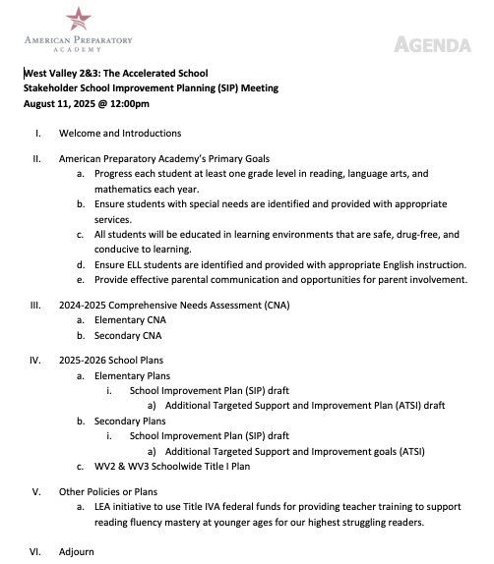
Describe the processes used to involve parents in the development of the schoolwide planning process. Attach copies of communications that were mailed or sent home, agenda with roll signatures, meeting notices, meeting minutes, etc.

American Preparatory administrators annually invite select staff and parents from each school to participate in a School Planning Meeting. This Committee reviews the Comprehensive Needs Assessment and analyzes areas for potential improvement. School Plans are developed with goals, action steps, and budget relationships. This meeting took place on August 11, 2025. The agenda is to the left. The sign-in sheet is on Page 1.

TSSA Plans, Early Learning Plans, Parent and Family Engagement Policies, and Parent/Student/School Compacts are reviewed by the School Community Council in a previous meeting. Input is collected and considered as the SIP is developed.

Describe how schoolwide plans will be made available to parents and the public in an understandable and uniform format.

The Schoolwide plan will be made available to parents on the school website and information will be published in a Fall newsletter.
Identify the parent involvement strategies that the school will use to involve parents.

See District Parent and Family Engagement Policy:
https://secure3.compliancebridge.com/amerprep/portal/getdoc.php?file=15

See School Parent Involvement Policy, located within the Parent-Student Handbook:
https://www.americanprep.org/parent-student-handbooks/

8. Transition from early childhood programs to local elementary school programs (Elementary schools only)
ESEA 1114 (b)(1)(G)
Refer to item #11 of the Utah Title I Part A Monitoring Handbook

In schoolwide program schools, there is clear evidence of transition activities between early childhood programs/home and the local elementary school.
Description of communication | Unlike neighborhood public schools, West Valley 2's kindergarten population is not based on geographical boundaries. Incoming students come almost exclusively from families with current students in the elementary or secondary grades. Communications about registration, immunizations, assessments, etc. begin in the Spring of the prior year through our weekly newsletters and through direct administrator/teacher contact with parents who have indicated they would like to enroll their student at West Valley 2.
Description of collaboration efforts | Incoming American Prep kindergarten students' parents are given a "KinderPrep" summer packet when they attend their assessment. This packet includes beginning skills to work on as well as a link to video resources.
Description of transition activities | When a student is enrolled at WV2, a series of assessments are given to the student to place them in an instructional level that matches the student's understanding of that subject. If the student passes it with 80% accuracy or better than a higher leveled test is given. Tests will continue to be given until the student does not pass. When the student does not pass, then we know what level of instruction is appropriate. When they do not pass the initial test with 80% accuracy or better, then a test that is lower in difficulty is given until the student does pass a test with 80% accuracy or better. This process occurs for reading and for mathematics.

9. Decisions regarding the use of assessments
ESEA 1114 (b)(1)(H)
Refer to item #12 of the Utah Title I Part A Monitoring Handbook

In schoolwide program schools, teachers are included in decisions regarding the use of assessments.

What assessments will be used to measure student progress and inform instruction? | The state standardized assessment administered. Acadience, SAT, Core Knowledge, College Readiness, and in-program Assessments will be used to measure academic success. It is anticipated that test scores will demonstrate increased proficiency that align with our school goals. For more information, visit: https://www.americanprep.org/state-assessments/
Please describe how teachers were included in decisions regarding the use of assessments. | - Teachers in weekly team meetings give feedback on assessments…which assessments should be used, when they should be taken, etc.  - Reading and math programs are assessed every 5 days. There are bi-monthly assessments every 2 weeks.

10. Students who experience difficulty mastering academic achievement standards
ESEA 1114 (b)(1)(I)
Refer to item #13 of the Utah Title I Part A Monitoring Handbook

In schoolwide program schools, procedures are in place to ensure that students who experience difficulty mastering any of the proficient or advanced levels of academic standards are provided timely and additional assistance.

How will the school identify which students experience difficulty in mastering academic standards? | When a student is enrolled at West Valley 2, a series of assessments are given to the student to place them in an instructional level that matches the student's understanding of that subject. If the student passes it with 80% accuracy or better than a higher leveled test is given. Tests will continue to be given until the student does not pass. When the student does not pass, then we know what level of instruction is appropriate. When they do not pass the initial test with 80% accuracy or better, then a test that is lower in difficulty is given until the student does pass a test with 80% accuracy or better. This process occurs for reading and for mathematics.
What interventions will the school provide for students experiencing difficulty in mastering academic standards? | - Every student receives core instruction through their classroom teacher. Intensive and accelerated instruction is taught in small groups at the student’s academic level in Reading, Language Arts, and Mathematics according to pre-assessments.  - Weekly evaluations are tracked and monitored by teachers, instructors, and directors to ensure mastery. Students who are falling behind are identified in weekly team meeting discussions. An action plan is developed to address the student’s needs.  - During follow-up team meetings, action plans are evaluated for effectiveness. Group level testing and change may be recommended if an action plan is not successful.  - Academic group levels are fluid. Teachers, instructors, directors, or parents may request a level test be administered at any time if they suspect that a different placement may be more appropriate for a child.  - Afterschool classes are offered for students who need extra academic support.
How will the school evaluate the effectiveness of the chosen interventions and make adjustments as needed? | Students are given assessments in reading and math every 5 to 14 days. The teacher records the data, and any student who does not pass one of these frequent assessments is recorded on a lesson progress chart (LPC). The LPC records which students are not at mastery in the current week. If the student is on this chart for 3 weeks in a row, then a group change is strongly considered. The teacher can also make recommendations that a student be reassessed at any time for a higher group change. Administration would look at the previous tests scores, homework scores and reassess if necessary. If a student passes an end-of-level assessment, then the student is moved out of the group immediately into the next higher group.

11. Coordination of Budgets (Federal, State, Local funds)
ESEA 1114 (b)(1)(J)
(#14 of Title I Part A Monitoring Handbook)

In schoolwide program schools, there is coordination and integration of federal, state, and local services and programs.

Program Funding Source | FY25 Allocations | FY26 Preliminary Allocations | Describe how the funding sources will support the schoolwide plan.
Title IA* | $639,103.49 | $754,491.00 | Positions supporting the district and campus goals/strategies/action steps above, which may include: Family & Community Engagement, Title I Coordinator, Academic Support Staff, Academic Extended Day Staff, translation, Instructional Support (Paraprofessionals/Teachers-in-Training), Professional Development, Academic Coaches, ELL instructors, Substitute Teachers, Supplemental IT, assistant teachers/instructors, College & Career Access, Senior Seminar, AP/CE teachers, Afterschool programs and staff, Parent Specialists, Credit Recovery, and/or student computer carts.
Title IIA* | $91,235.00 | $91,235.00 | Teacher Training and/or Academic Coaches
Title IIIA* | $143,449.17 | $112,088.24 | EL Professional Development, Direct Instruction Spoken English (DISE) & Intensive English Instruction, District Support
Title IVA* | NA | $53,942.98 | These funds have transferred to Title IIA to provide teacher training to support reading fluency mastery at younger ages for our highest struggling readers. Interventions such as LIPS, Seeing Stars, and Visualizing & Verbalizing accelerate reading gains, particularly for students with dyslexia or other learning differences.
IDEA School Age* | $796,010.42 | $829,707.53 | SpEd Caseworkers and Contracted Speech, Occupational Therapy, and other Services, Special Education Teachers (SETs) and Assistant Special Education Teachers (ASETs)
At-Risk* | $1,300,260.26 | $1,391,590.02 | Counselors, Ambassador Character Development Leaders, Academic Extended Day, Afterschool, and/or Early Learning staff
Accelerated Students (GT, AP, CE)* | $67,130.48 | $67,130.48 | Gifted and Talented (GT): Teachers and instructors providing Saxon 8/7 & Algebra classes to 5th & 6th grade students. AP: AP test fees for eligible students. AP & Continuing Education (CE): Additional college ready course opportunities (if available).
School Land Trust (WV2&WV3) | $219,474.2 | $242,066.35 | Salary support for instructional staff.
TSSA (WV2&WV3) | $253,143.14 | $ 509,356.98 | Salary increases (40%), Instructional support (paraeducators/ teachers-in-training), counseling support, CE class offering, Philosophy class offering, full-time secondary substitute, college access advisor, secondary academic coaches (MASTER Teacher Leader Program), and student computer cart if funds allow.
Sistema Afterschool Grants* | $87,250.00 | $ 403,250.00 | Includes a legislative appropriation as well as a variety of government, business, and private grants that support the K-6 Sistema afterschool programs at our Title I schools.
GEAR UP Cohort 3 | $59,643.32 | NA | Cohort-specific college & Career Readiness activities which may include college campus visits, leadership opportunities, afterschool programs, credit recovery, STEM & career clubs, etc.
GEAR UP Cohort 5 | $217,070 | $217,070 | Cohort-specific college & Career Readiness activities which may include college campus visits, leadership opportunities, afterschool programs, credit recovery, STEM & career clubs, student computer lab carts, etc.
*These are LEA budgets. The actual school distribution will be smaller.

12. Title I LEA Plan Requirements
SY26 APA's Title I LEA Plan

